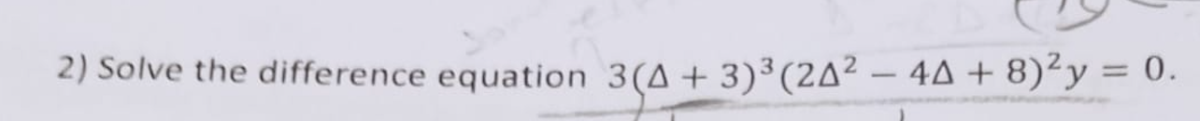
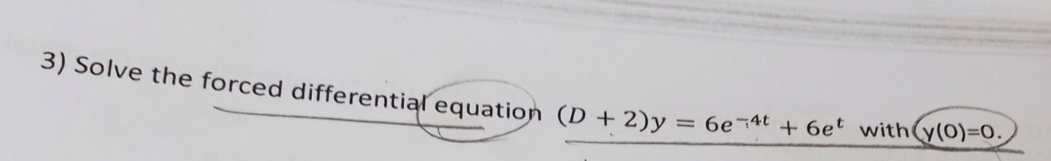
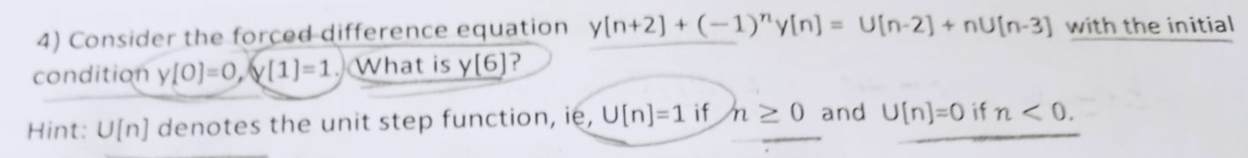
MATH2055 Differential Equations Midterm-2024
Mehmet Kadir Baran

